**Project title**

**Jesper Bertelsen, Mads Jakobsen**

# **Project plan**

## **Introduction**

As students we find that money are limited. Home control systems are an expense, that’s a luxury, that isn’t a priority among us.

Here you can introduce various components that you are going to use including the mandatory ones (Input/Output devices: LCD, Keypad and Buzzer – Sensors: DHT11, Ambient light sensor, PIR sensor and Smoke detector sensor – Arduino board) and the extra devices that maybe you want to add to your project.

Moreover, describe the application of your system (e.g. protecting house against fire, robbery, controlling enviroment, etc. and the features of inviroment that you are going to control)

<https://stock.ece.au.dk/components/details/146> - Ultrasonic module - Rangefinder

<https://stock.ece.au.dk/components/details/135> - Color Sensor

<https://stock.ece.au.dk/components/details/148> - UV Sensor

<https://stock.ece.au.dk/components/details/156> - Fingerprint scanner

<https://stock.ece.au.dk/components/details/166> - Bend sensor

Første ide, indbrudsalarm: PIR til at tjekke bevægelse, alarmer. Skriv adgangskode for at slå den fra, slå den fra inden for 2 min ellers send besked til ejer? Imens buzzer lyd, flashende display, tryk på * for at skrive adgangskode for at af alarmere

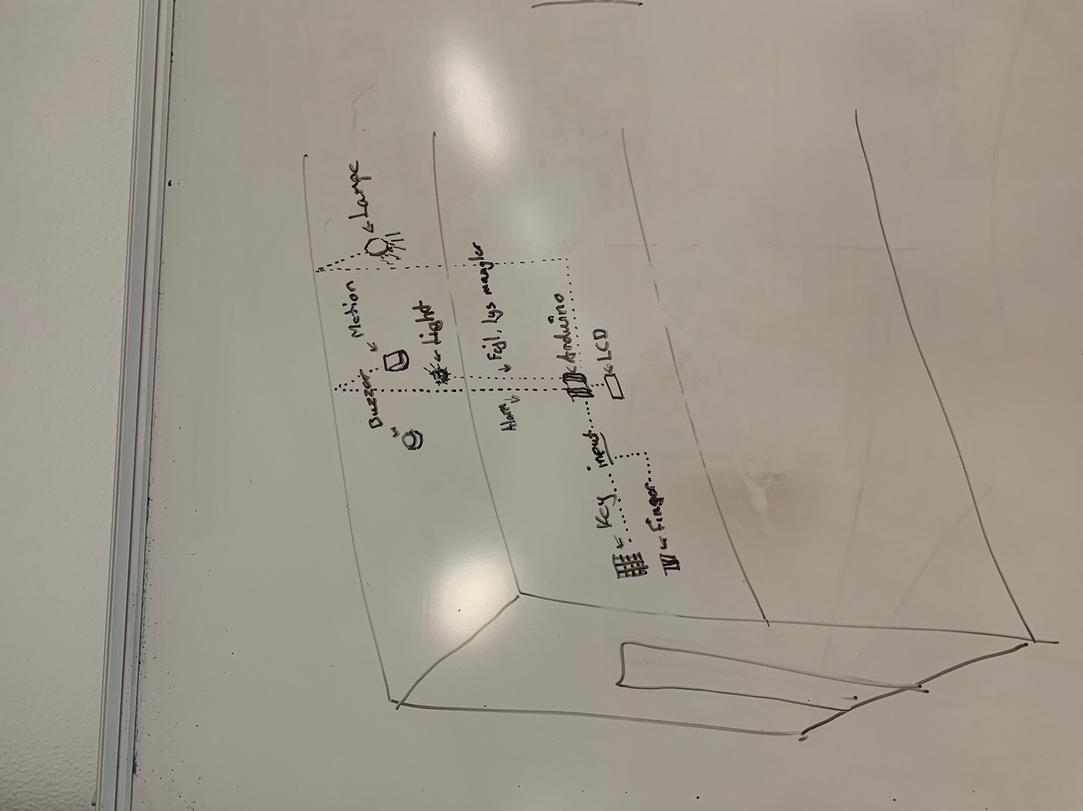

Input:

* Keypad
* Finger scan
* Wireless connection: Af alarmer fra mobiltelefonen.

Alarmer:

* Motion detector

Output:

Alarm:

* + Buzzer
  + Blinkende lys
  + Blinkende display

Godkendelse:

* + Hold lyset tændt.
  + Alarm stop
  + Send data til firebase ( Kan bruges som plan til at udvide projektet, brugerflade kan laves til at udnytte data )

Kræver:

* Fingeraftryks scanner
* Wireless module, til at sende data til og fra firebase.

Planen:

* Lær om wireless module
* Setup koden
* Test af externe moduler ( Finger scan og wireless )
* Saml systemet.

Anden idé:

* Som studerende, som også laver andet end at gå i skole, og dermed har os et liv, så vil vi lave noget, som vi selv kan bruge.

En system bygget til at styre forskellige ting, som kan være relevante for os.

* En keypad som skal vælge mellem funktioner:
  + Stem guitar, række følge: E, A, D, G, B, E. Skift mellem rækkefølge ved klik af arduinos knap.
  + Metronome til at holde takten.
  + Til at spille baggrunds akkorder:
    - Gennem firebase kan man indstille en liste med gennemsnitsfrekvenser svarende til akkorder. Efter et tidsinterval, indstillet på firebase, så skifter den til næste akkord. Vha. af en for loop kan vi dæmpe akkorden over tid, så det virker realistisk, som om det var spillet på et akustisk instrument.
  + Mulighed for mange andre funktioner.

## 

## **1-2 General plan/overview**

This section will describe the general plan of the project including how different sensors, processing unit and input/output devices will be connected and used together. How you will use the data sensed from sensors. How the data read from input devices will be used to make a decision about an action.

For example:

*User interface:*

1. *Show a welcome message for 2 second.*
2. *Ask the user to select between setting and operation.*
3. *In case operation is selected, the system should work based on default settings.*
4. *If setting is selected, first, ask user to enter a password. The user is allowed to type wrong password 3 times and after that system should block and start to alarm.*
5. *In setting, user can decide about XXX, YYY, and ZZZ thresholds and also.*
6. *…*

*Decision making:*

*In this project, we are going to sense XXX, YYY and ZZZ. Based on the sensed data, different types of decisions can be made by this system as follows:*

1. *Fire alarm: the smoke level will be read by smoke detector sensor. If the level of smoke will be higher than xxx, the temperature will be read from DHT11. Then, in case temperature will be higher than 40°C, the buzzer start to alarm and the LED start to blink.*
2. *Lightening: …*
3. *…*

## **2-2 Flow chart of the system**

Convert the general plan of previous section to a flowchart (See Fig 1). The flowchart should show the workflow of your project. You can add some description about different parts of your flowchart here.

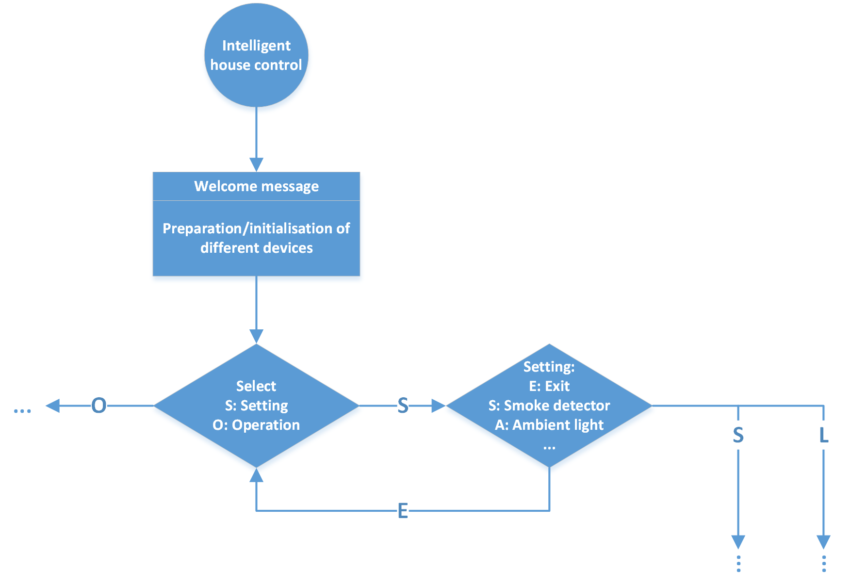

Fig 1. Flow chart example

# **Style**

This template is provided based on the required style requirements. Hence, you can just copy paste your text inside this template without changing the style. In general, the style requirements are as follows:

**Page layout:** For page layout use 2cm margin for left, right, top and bottom margins.

**Font:** For font of the context use Time new roman, 12 font size. For the section heading use font size of 20 (Bold) and for the subsections use font size of 16 (Bold). For the captions of figures and tables use font size of 11.

**Line spacing:** For the line spacing use 1.5.